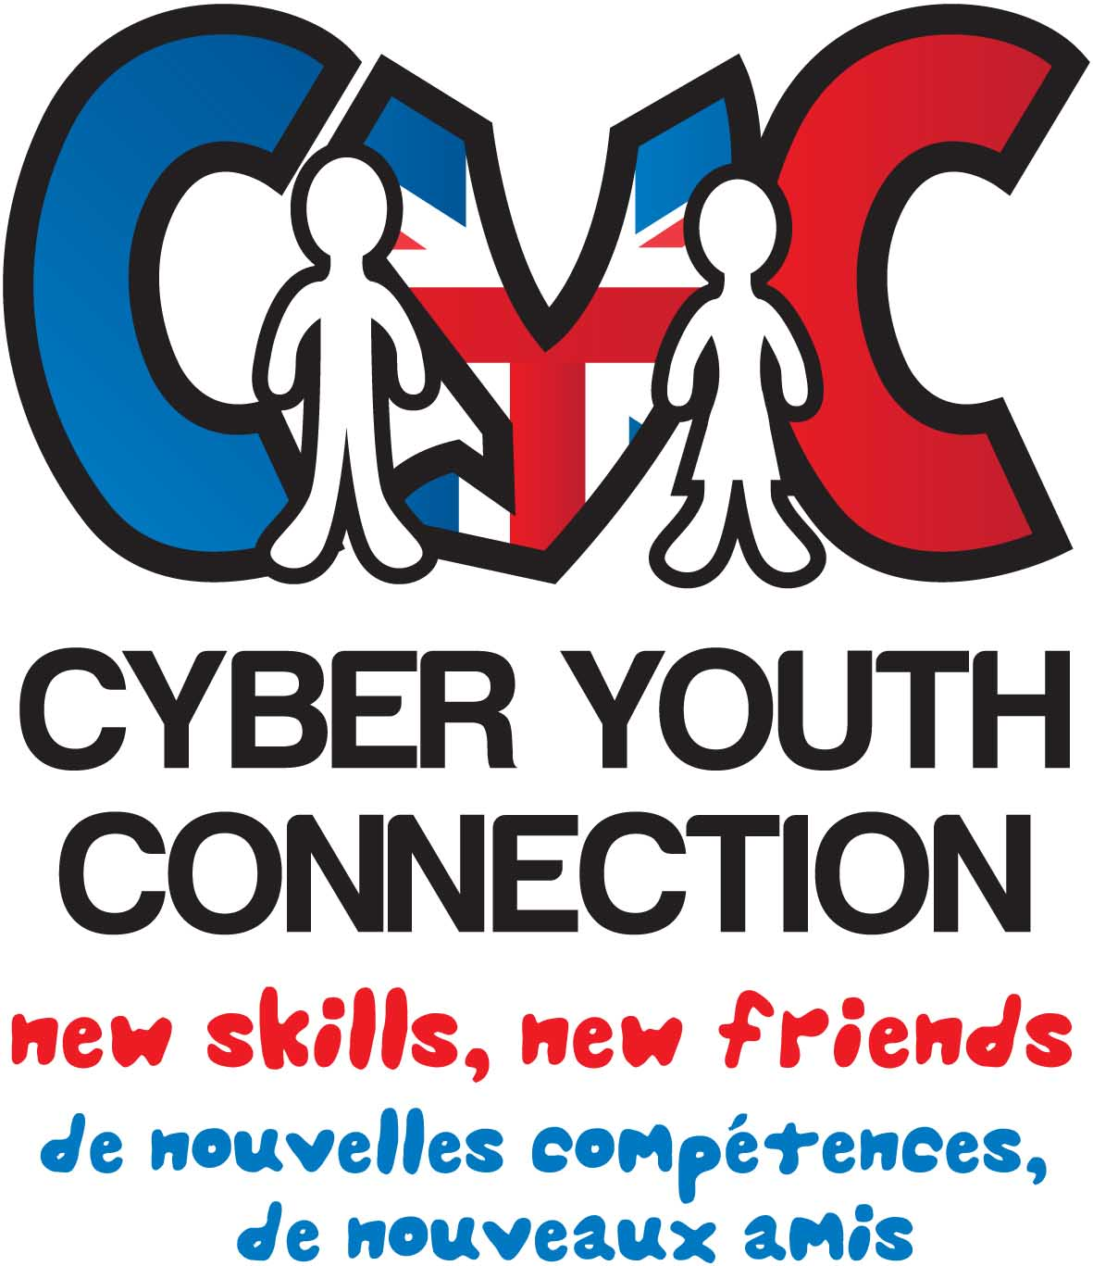
Grande finale Cross Border Show!
Medway.
2013
2014
2012
Building on young peoples skills and confidence at local level to get them to a standard for cross border shows.
Oct - Medway WP3 Workshops & Cross Border Talent Show
Small Community Talent Show in Suffolk/Medway/
Pas De Calais/Brest(2)

April – Cross Border Workshop, Pas De Calais
July - Suffolk Host 4 Day Workshop
All partners exchange acts through video and create a Cyber Cross Border Talent Show.
Feb – Cross Border preparation Workshop, Brest
YP exchange & help deliver community show
Arque Talent Show
April – Annual Talent Show event, Brest
2015
Work Package 3 Timeline
2012 - 2015
Project Targets 2012 – 2015
- Minimum of 470 local workshops (18 per partner per year)
- Monthly Cyber Session – 30 Mandatory & 25 Drop in
- Minimum of 10 Talent Shows

